LAB EXPERIMENT 5
Assignment 5
(Exercise on retrieving records from the table)
EMPLOYEES (Employee_Id, First_Name, Last_Name, Email, Phone_Number, Hire_Date, Job_Id, Salary, Commission_Act, Manager_Id, Department_Id)
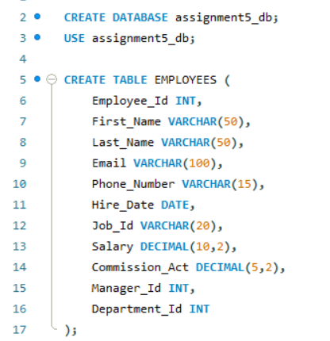
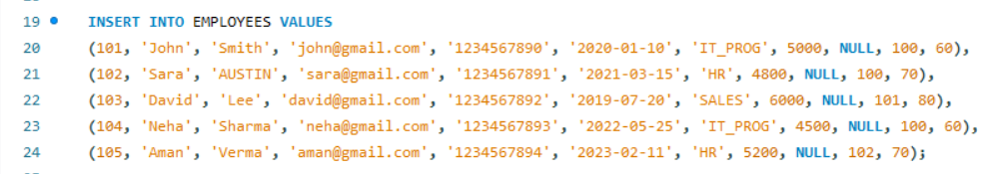
( a) Find out the employee id, names, salaries of all the employees
QUERY:
RESULT:
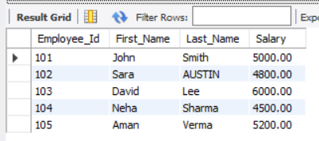
( b) List out the employees who works under manager 100
QUERY:

RESULT:
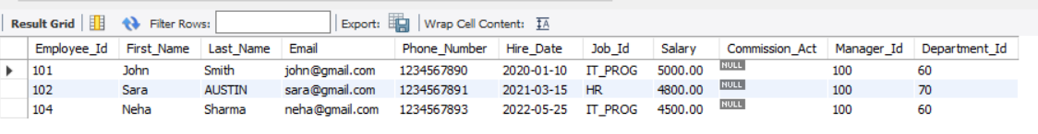
( c) Find the names of the employees who have a salary greater than or equal to 4800
QUERY:
RESULT:
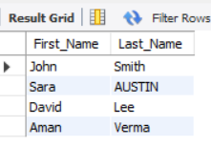
( d) List out the employees whose last name is ‘AUSTIN’
QUERY:
RESULT:
( e) Find the names of the employees who works in departments 60,70 and 80
QUERY:

RESULT:
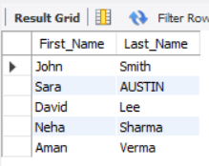
( f ) Display the unique Manager_Id
QUERY:

RESULT:
